PROPOSED MULTI-USE GAMES AREA (MUGA)
LAUNCESTON ROAD RECREATION GROUND

What is your gender?:

Male Female Other Rather not say

Which of the following age category applies to you?:
Under 12

12 -16

17 - 24

25 - 50

50+

Do you belong to a sports club/organisation/group?

Yes No

Which one? ………………………………………………………….

Do you live in Callington Kelly Bray Out of Parish

How often do you visit Launceston Road Recreation Ground?
Daily

Weekly

Monthly

Very occasionally

Never

What do you do when you visit Launceston Road Recreation Ground?
Personal exercise

‘Hang Out’

Picnic

Bring children to play

Other

Callington Town Council is considering a proposal to install a MUGA at Launceston Road Recreation Ground which would benefit the community, school and local clubs. Do you support this proposal?

Yes No

If we gain funding for a MUGA what activity do you think you would play?
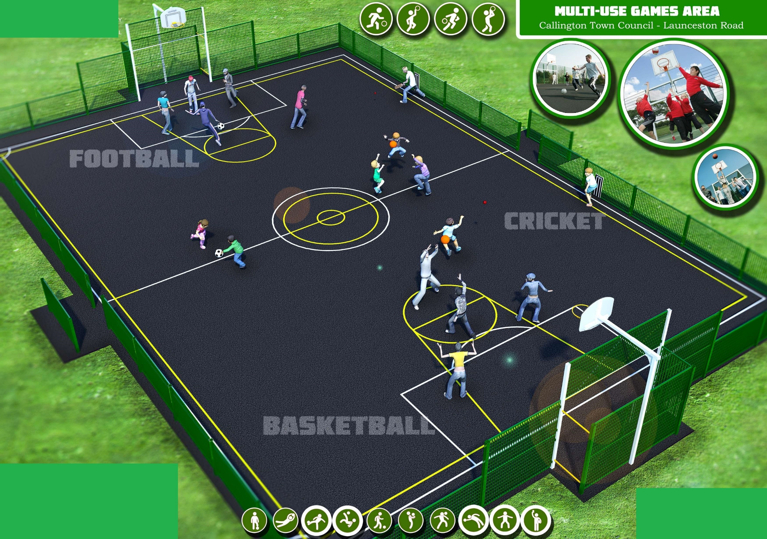
Basketball

Football

Cricket

Other

Design of a MUGA

Thank you for taking the time to complete this form which will help the Town Council with their bid for funding.

Please return this form to Callington Town Council, New Road, Callington, PL17 7BD or by email to - enquiries@callington-tc.gov.uk

